**USER HANDBOOK**

**PROJECT 1 : ADDRESS BOOK**

Edited by

Frazer Bayley

Haley Whitman

Abdulaziz Al-Heidous

Alison Legge

Jeremy Brennan

Project 1 - Team 3

**Contents**

1 Introduction 3

1.1 A Simple Address Book 3

1.2 How to Use this Handbook 3

2 Getting Started with the Address Book 4

2.1 Download and Install 4

2.2 Starting the Application 4

3 Adding Contacts 5

3.1 Overview 5

3.2 Procedure 5

4 Selecting Contacts 9

4.1 Overview 9

4.2 Procedure 9

5 Editing Contacts 11

5.1 Overview 11

5.2 Procedure 11

6 Deleting Contacts 13

6.1 Overview 13

6.2 Procedure 13

7 Sort Address Book 14

7.1 Overview 14

7.2 Procedure 14

8 Search 15

8.1 Overview 15

8.2 Procedure 15

9 Create New Address Book 17

9.1 Overview 17

9.2 Procedure 17

10 Save Address Book to File 19

10.1 Overview 19

10.2 Procedure 19

11 Save As and Renaming Your Address Book 21

11.1 Overview 21

11.2 Procedure 21

12 Open Existing Address Book 23

12.1 Overview 23

12.2 Procedure 23

13 Close Address Book 25

13.1 Overview 25

13.2 Procedure 25

14 Quitting the Application 27

14.1 Overview 27

14.2 Procedure 27

**Revision History**

**Revision Date Author(s) Description**

.1 26.01.17 Frazer Bayley Created the first draft of the document, 1 - 9.

.2 28.01.17 Frazer Bayley Adding more of the functionality, 10 - 15.

.3 30.01.17 Frazer Bayley Adding screenshots.

.4 01.02.17 Frazer Bayley Added Getting Started and more screenshots. Final

Change.

# 1 Introduction

## 1.1 A Simple Address Book

Thank you for using this simple Address Book. This Address Book is designed for an average person who may hundreds of contacts. It provides functionality that you would expect to have in a simple Address Book, such as adding contacts, editing or deleting a contact, and importing and exporting several different address files.

## 1.2 How to Use this Handbook

This handbook covers a range of scenarios you might encounter when using this Address Book. This handbook will walk you through each scenario step by step. • **Read Every Step:**

Make sure you do not skip any steps that are listed in this handbook. Every step has been carefully thought out to make using the Address Book easier. • **Use the Handbook in Conjunction with the Address Book:**

After your first read through of the handbook have it open and ready as you first start to use the Address Book. • **Experiencing Issues:**

If you are experiencing further issues and are unable to solve it with the help of this handbook, please contact our support team.

# 2 Getting Started with the Address Book

## 2.1 Download and Install

The development team will have sent you the addressBook.jar file that launches the application. In case you did not receive or lost the addressBook.jar file please go to *https* : *//github.com/WhitmanH/CIS* 422 *Scheduler* to download the addressBook.jar file.

Use the LaTeX command:

\usepackage{hyperref}

\href{https://github.com/WhitmanH/CIS-422-Scheduler}{Address Book}

## 2.2 Starting the Application

To launch the application select and open the addressBook.jar file. This will immediately launch the Address Book application. If for some reason the application does not open, go to your command line interface and cd into the directory in which the application file sits. Then type the command: ”java -jar addressBook.jar”, the Address Book will then open in another window. If you have further problems, please contact Team Robosharks. Enjoy!

# 3 Adding Contacts

## 3.1 Overview

Adding a new contact is easy to do in this Address Book. It will only take a few clicks.

## 3.2 Procedure

#### 1) Begin at the Main Page

Below are two images of the main page to help you verify you are where you need to be.

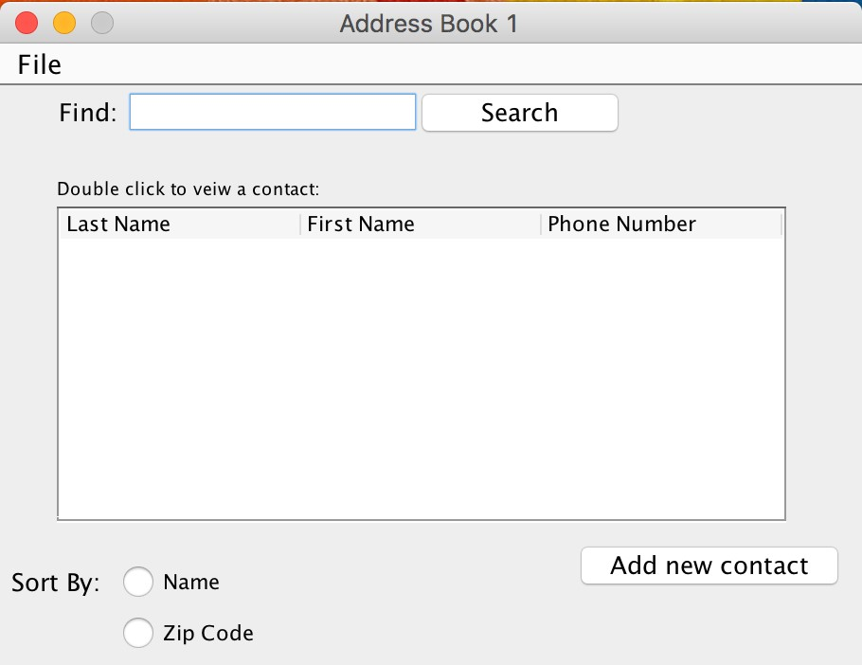

Figure 1: Empty Main Page

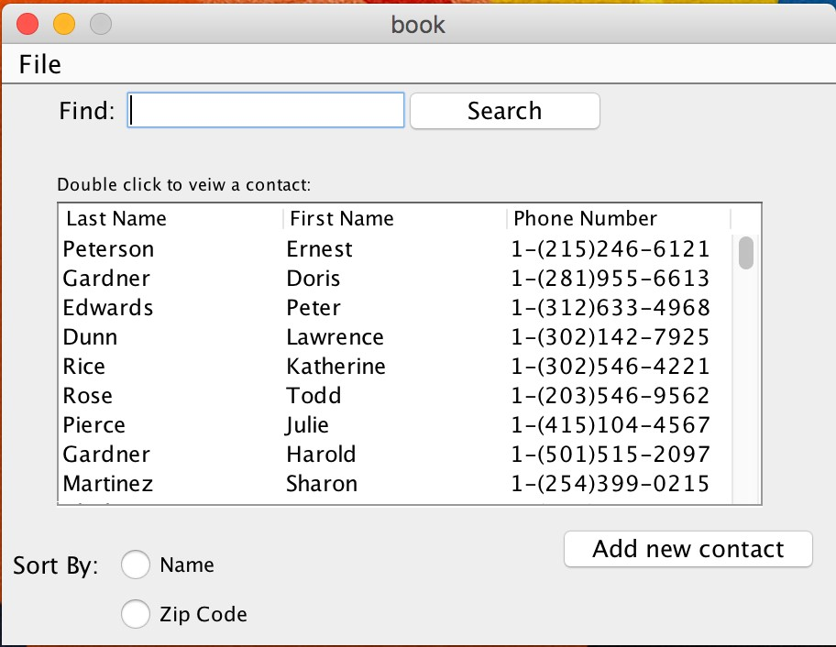

Figure 2: Full Main Page

#### 2) Click the ”Add Contact” Button

You will see an ”Add Contact” button on the main (Call this Main Page, as that’s what the figure is referring to, or change figure)window. Move the mouse to it and click the ”Add Contact” button. Upon clicking the Add Contact window will appear.

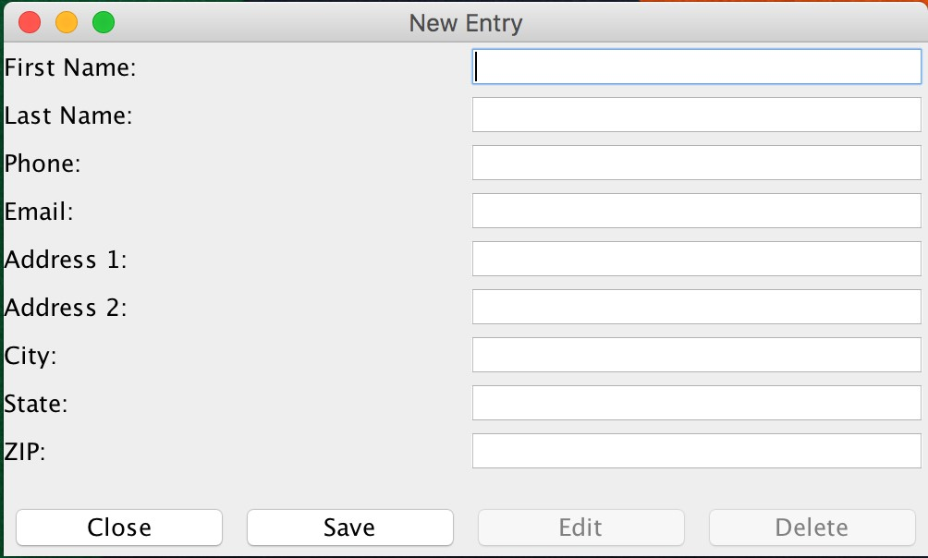

Figure 3: Add Contact Window

#### 3) Fill In Contact Data

The Add Contact window has multiple fields for you to fill in with Contact information. You are required to enter a first name or a last name, plus a second entry of the ones laid out. There must be another entry besides both the first and last names.

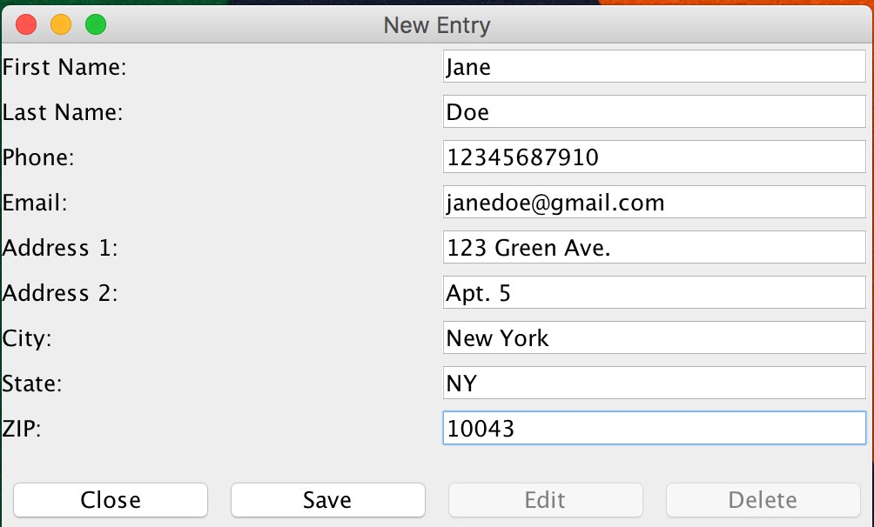

Figure 4: Contact Entries

#### 4) Save New Contact Information

When you have entered all the information you wish to enter about your new contact click the ”Save” button. This will permanently save the Contact to the Address Book. If you haven’t entered all the required information detailed in the last step an error message will appear. This error message will direct you back to the Add Contact window. The error will not go away until the information is entered correctly.

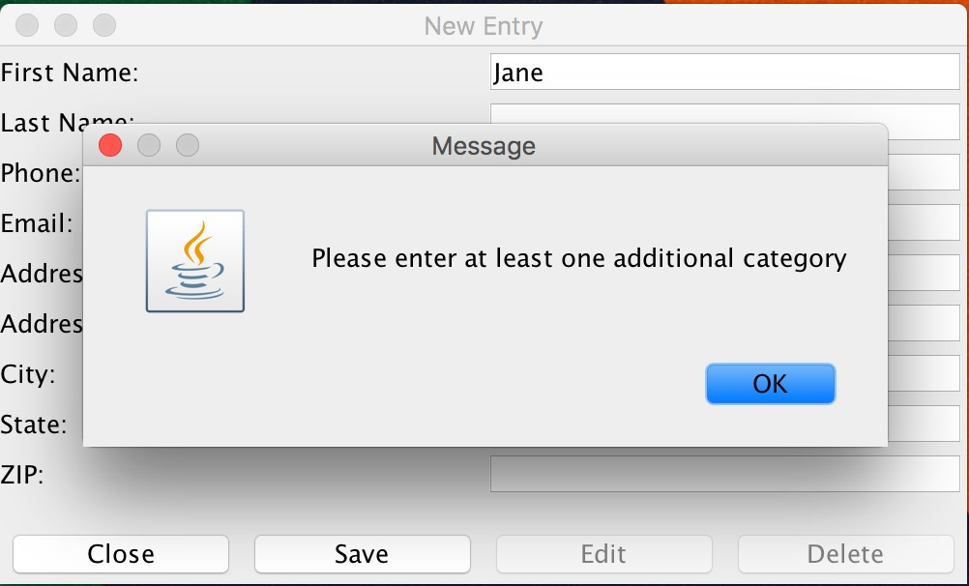

Figure 5: Not Enough Entries

#### 5) Close Add Contact Window

Now that you have saved the Contact information, click the ”Close” button. This will close and remove the Add Contact window from the screen. If you have not saved the information before this step a dialogue box will appear asking you if you would like to Save the new information or Discard the new information.

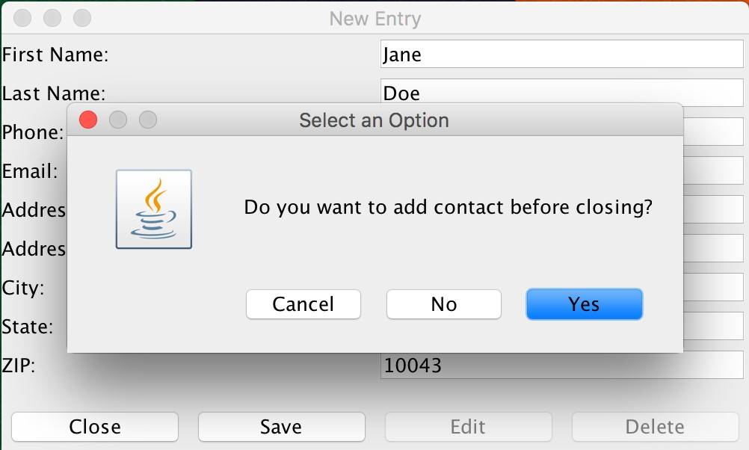

Figure 6: Prompt to Save

After this step you will be left with the Main page of the Address Book. If you scroll through the entries you will see your newly added Contact listed.

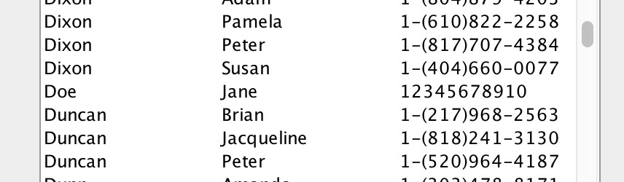

Figure 7: New Entry Added to Address Book

# 4 Selecting Contacts

## 4.1 Overview

You will eventually need to look at the information of a Contact in your Address Book. Here is how to do so.

## 4.2 Procedure

#### 1) Begin at the Main Page of a Non Empty Address Book

To use this feature you must have at least one Contact in your address book.



Figure 8: Full Main Page

#### 2) Find Contact For Selection

Find the contact you would like to Select by scrolling through the list of Contacts. Hover your mouse over the desired Contact.

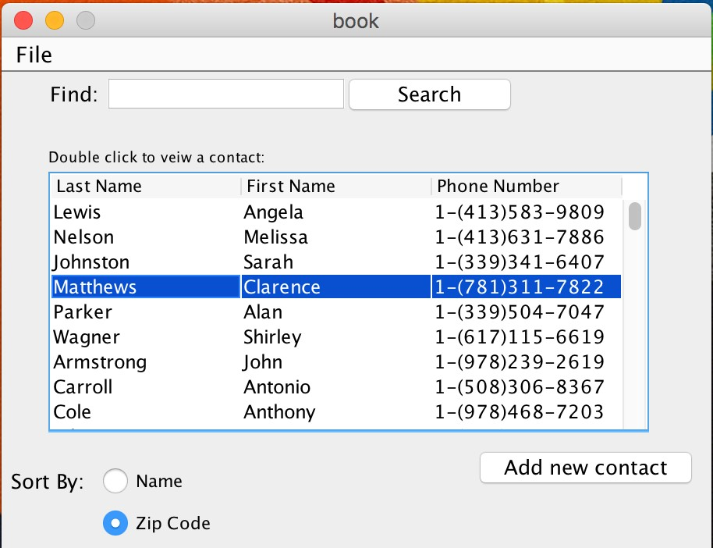

Figure 9: Selecting a Contact

#### 3) Double Click Contact

With the mouse over the desired Contact, double click the Contact. This will make the Contact information appear in another window.

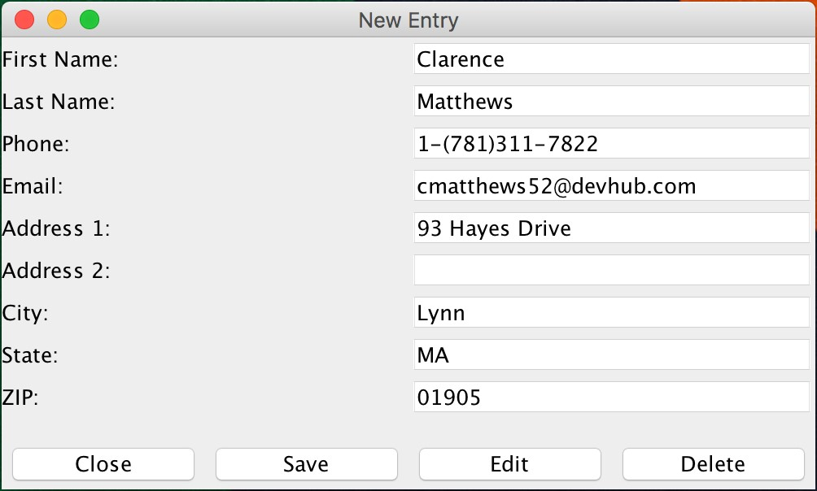

Figure 10: Viewing Contact

#### 4) Close Window

Once you are done with viewing the contact information, click the ”Close” button. This will remove the Contact window from view.

# 5 Editing Contacts

## 5.1 Overview

If you wish to make changes to an existing contact the steps below detail how to do so.

## 5.2 Procedure

1. **Select Contact for Editing**

Complete steps 1, 2, and 3 of the ”Selecting Contacts” section of this handbook.

1. **Click the ”Edit” Button**

You should be looking at the Contact information page. Click the ”Edit” button.

#### 3) Edit Information

This will make it so the the information in the field boxes are editable. Change or add any information you desire.

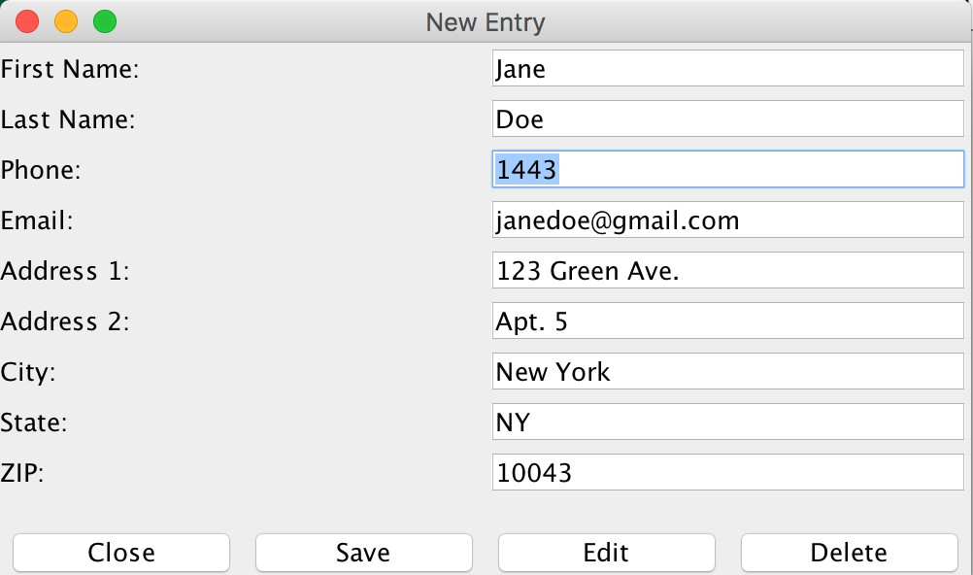

Figure 11: Editing a Contact

**4**) **Save Newly Edited Information**

Click the ”Save” button to permanently save the changes you have made to the Contact.

#### 5) Close Window

Once you are done with saving the contact information, click the ”Close” button. This will remove the Contact window from view. If you haven’t clicked the ”Save” button before this step a dialog box will appear asking you if you want to Save the changes you have made or to Discard them.

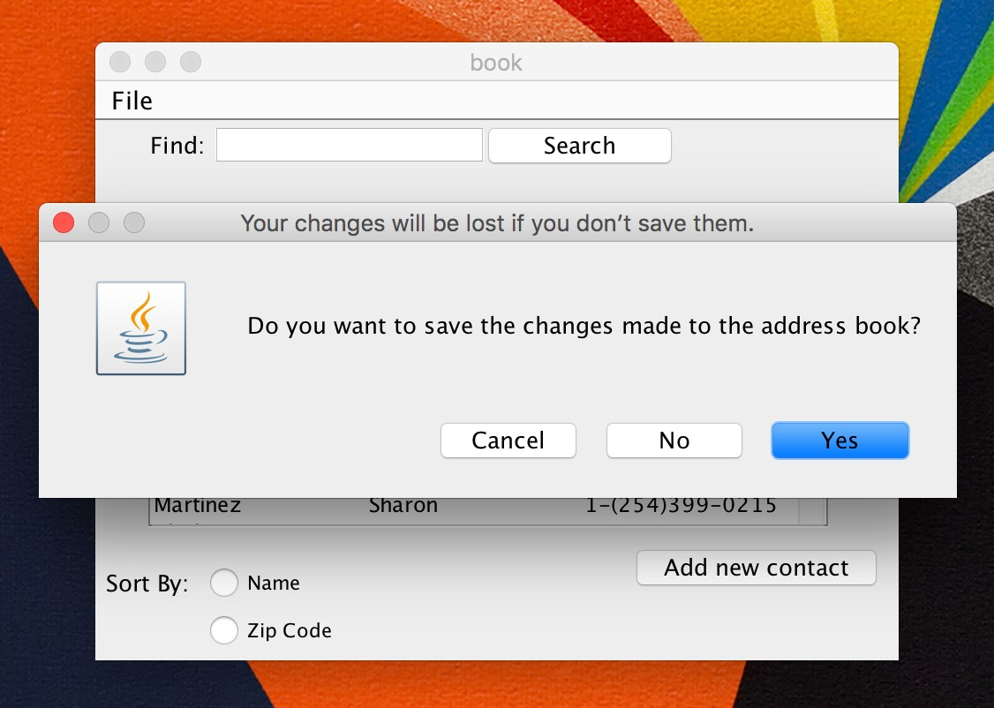

Figure 12: Prompt to Save

# 6 Deleting Contacts

## 6.1 Overview

If you wish to remove a Contact completely from your Address Book follow the steps below.

## 6.2 Procedure

**1**) **Select Contact for Editing**

Complete steps 1, 2, and 3 of the ”Selecting Contacts” section of this handbook.

#### 2) Click the ”Delete” Button

You should be looking at the Contact information page. Click the ”Delete” button. Once you have clicked the Delete button a dialogue box should appear asking if you are sure about your decision to delete. If you are sure, click ”Yes”, if not, click ”No”.

After you select ”Yes” the Contact information window will disappear from view. If you selected ”No” you will have to follow the normal procedure of closing the window detailed in previous sections to remove the Contact Information from view.

# 7 Sort Address Book

## 7.1 Overview

If you want to see the list of contacts in either descending by last name or ascending by ZIP code then follow these steps.

## 7.2 Procedure

#### 1) Begin at the Main Page of Non Empty Address Book

For this feature to work your Address Book must contain at least two Contacts.



Figure 13: Full Main Page

#### 2) Order by Last Name

Click the button that says ”Order by Last Name”. Once selected you will see the ordering change as long as it wasn’t in that order before.

There is no button, it is “Sort By” and radio buttons.

#### 3) Order by Zip Code

Click the button that says ”Order by Zip Code”. Once selected you will see the ordering change as long as it wasn’t in that order before.

There is no button, it is “Sort By” and radio buttons.

# 8 Search

## 8.1 Overview

If you would like to find a specific Contact without scrolling through the list of them follow the procedure below.

## 8.2 Procedure

#### 1) Begin at the Main Page of Non Empty Address Book

For this feature to work your Address Book must contain at least two Contacts.



Figure 14: Full Main Page

#### 2) Find the Search Bar

On the page there will be a field where you can make entries.

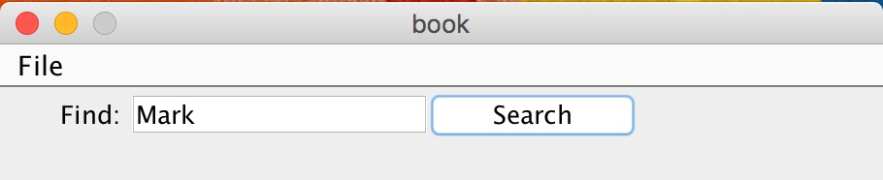

Figure 15: Search Bar

#### Enter Your Search

In the text entry field enter anything related to the Contact you wish to view. Once you type your query, click ”Search”. If any contacts match your query they will present themselves in the scroll box.

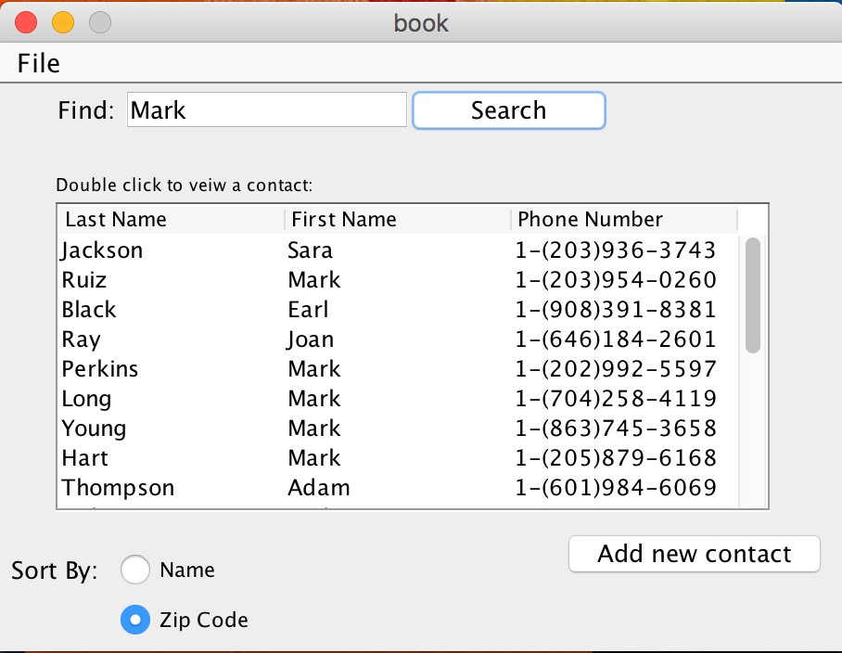

Figure 16: Search Results

#### 4) Getting Out of Your Results

To go back to the main page with all your Contacts clear the Search bar of text and click ”Search”.

# 9 Create New Address Book

## 9.1 Overview

When you first launch the Address Book application you will always open up to a ”New” address book. If you would like to create a new address book when you have an existing address book already open follow this procedure.

## 9.2 Procedure

**1**) **Begin at the Main Page of the Address Book** Make sure you are at the Main page of the Address Book.



Figure 17: Full Main Page

#### 2) Select the File Menu

At the top of the Main page window there will be a button ”File”. Select it and a menu will pop open.

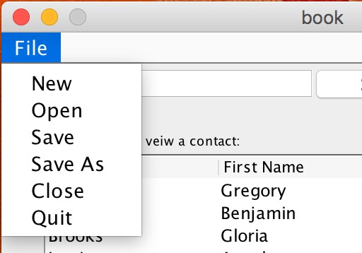

Figure 18: File Menu

#### Select ”New”

Click the ”New” option in the menu. This will create a blank Address Book in another window.

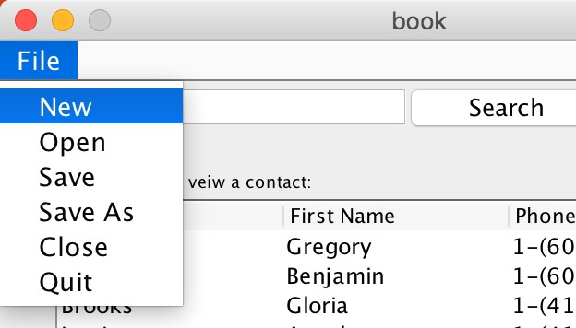

Figure 19: Select New

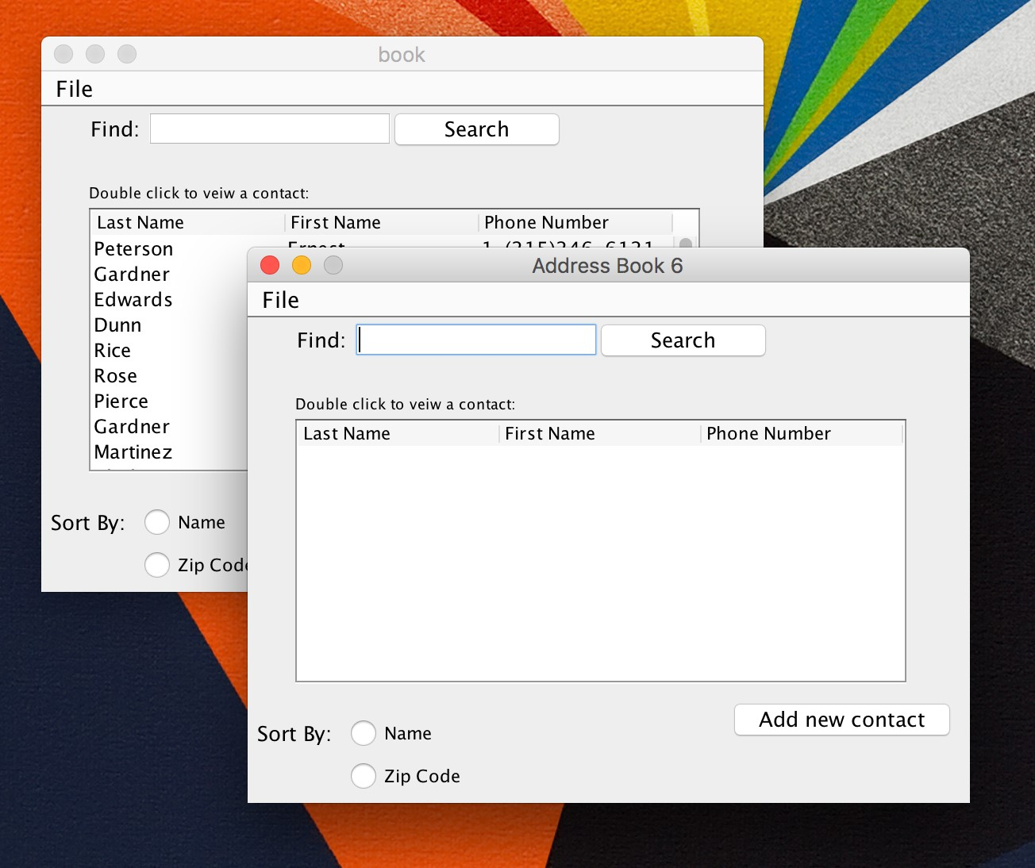

Figure 20: New Address Book

Now you can use your New Address Book.

# 10 Save Address Book to File

## 10.1 Overview

At some point you will want to save the entire Address Book. The procedure below walks you through how to do so.

## 10.2 Procedure

**1**) **Begin at the Main Page of the Address Book** Make sure you are at the Main page of the Address Book.



Figure 21: Full Main Page

#### 2) Select the File Menu

At the top of the Main page window there will be a button that reads ”File”. Select it and a menu will pop open.



Figure 22: File Menu

#### Select ”Save”

Click the ”Save” option in the File menu. This feature will Save the Address Book to a predetermined file, the file you opened the Address Book from. After you have clicked ”Save” the Address Book and its entire contents will be safely stored.

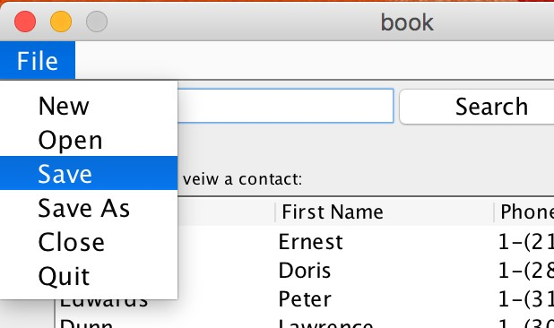

Figure 23: Select Save

# 11 Save As and Renaming Your Address Book

## 11.1 Overview

If you would like to Save your Address Book under a di↵erent name and/or in a di↵erent location follow the below procedure to do so.

## 11.2 Procedure

**1**) **Begin at the Main Page of the Address Book** Make sure you are at the Main page of the Address Book.



Figure 24: Full Main Page

#### 2) Select the File Menu

At the top of the Main page window there will be a button that reads ”File”. Select it and a menu will pop open.



Figure 25: File Menu

#### Select ”Save As”

Click the ”Save As” button and a pop up window will appear.

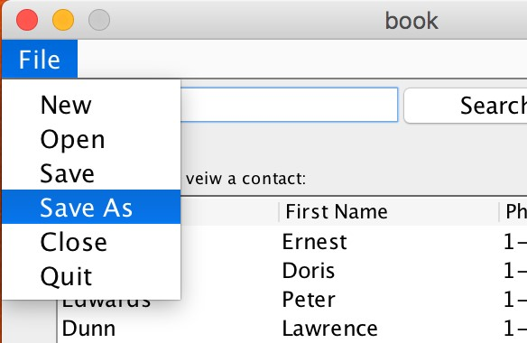

Figure 26: Select Save As

#### 4) Write in New File Name

In the new window you will be asked for a new file name and where to save the file. Make your choices and then hit ”Save”. After this step your Address Book will have a new name and file path.

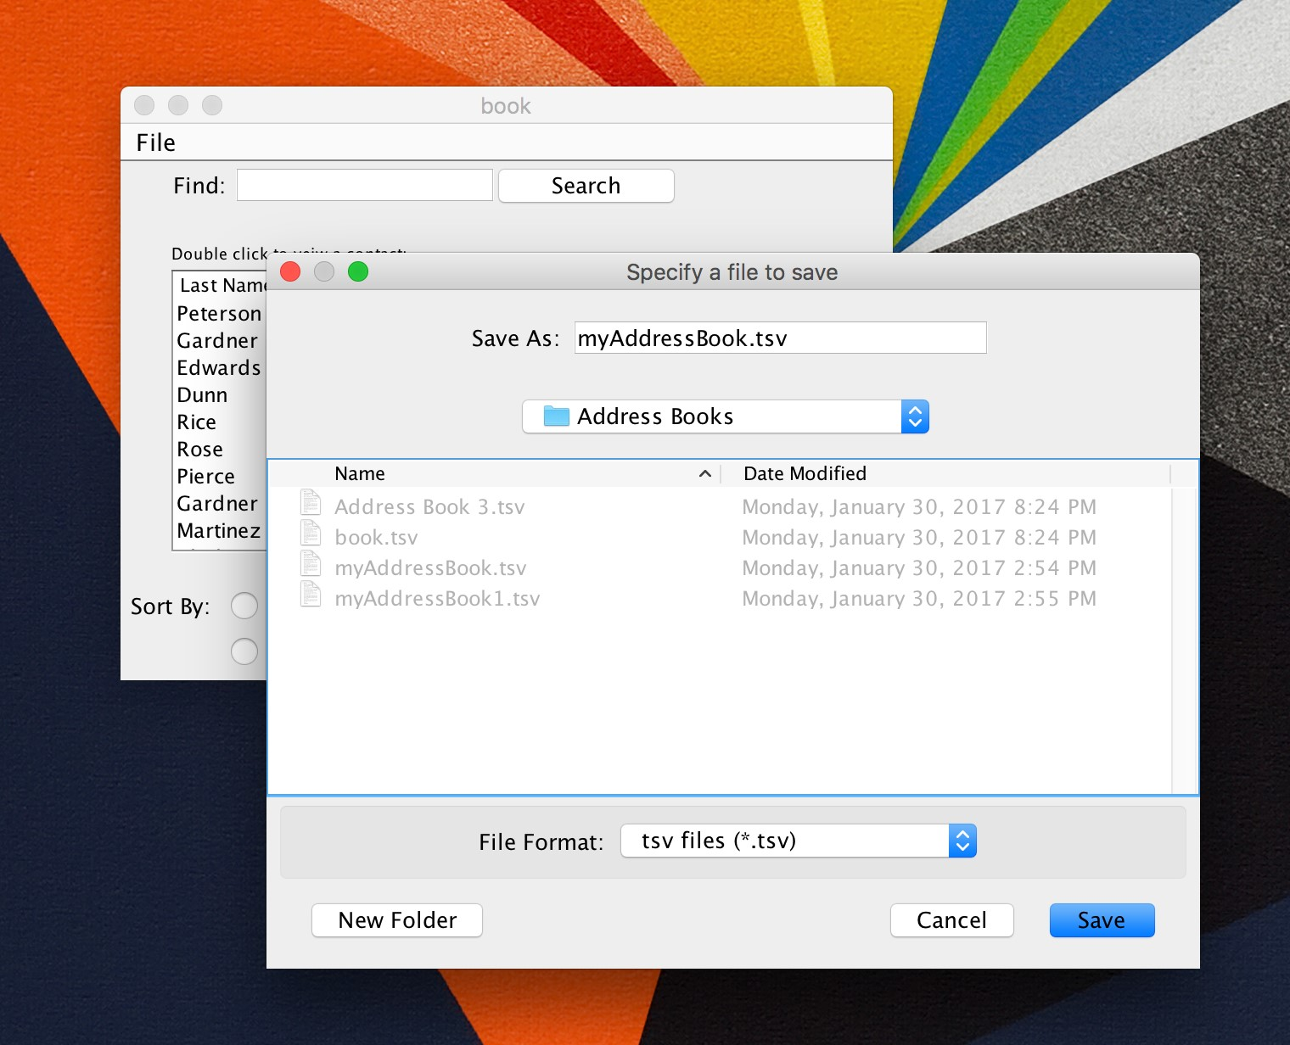

Figure 27: Save As Window

# 12 Open Existing Address Book

## 12.1 Overview

If you want to Open an existing Address Book follow the procedure below.

## 12.2 Procedure

**1**) **Begin at the Main Page of the Address Book** Make sure you are at the Main page of the Address Book.



Figure 28: Full Main Page

#### 2) Select the File Menu

At the top of the Main page window there will be a button that reads ”File”. Select it and a menu will pop open.



Figure 29: File Menu

#### Select ”Open”

Click the ”Open” button and a pop up window will appear.

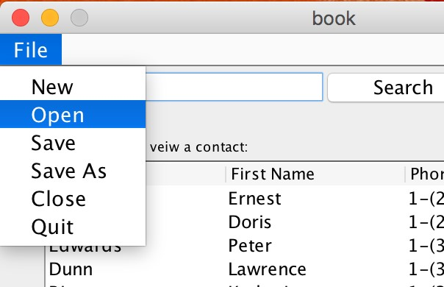

Figure 30: Select Open

#### 4) Select File

In the new window you will be shown a list of file names. Any file names that end in ”.tsv” can be opened by the Address Book application. Select the file you wish to Open and then click the ”Open” button. Upon clicking ”Open” the Address Book you chose will appear.

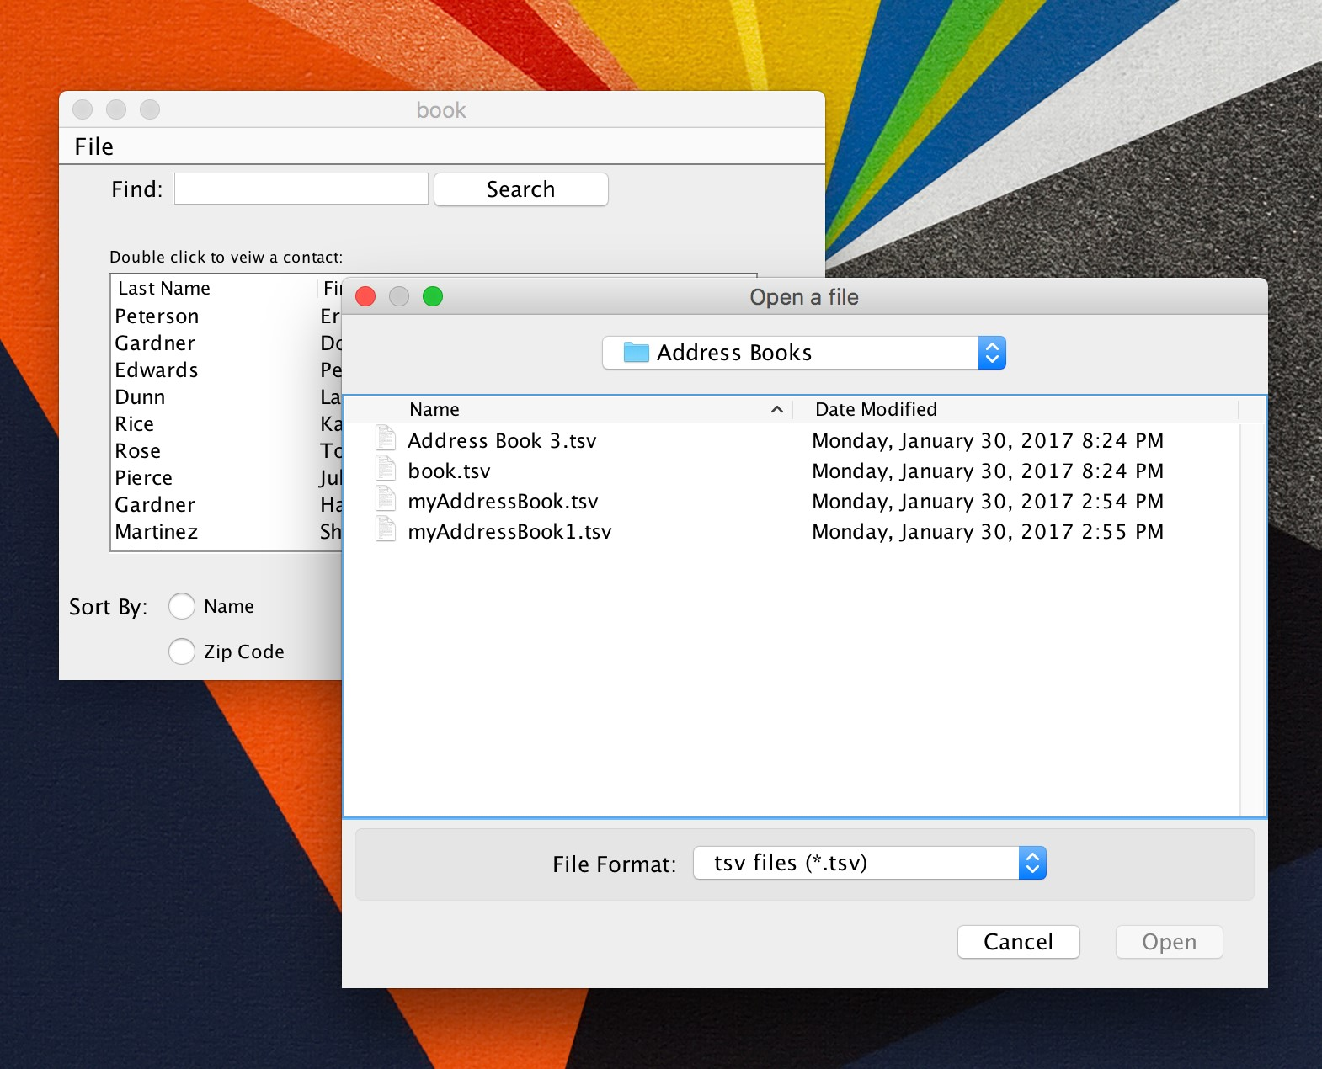

Figure 31: Open Window

# 13 Close Address Book

## 13.1 Overview

You can Close an Open Address Book by following the procedure below.

## 13.2 Procedure

**1**) **Begin at the Main Page of the Address Book** Make sure you are at the Main page of the Address Book.



Figure 32: Full Main Page

#### 2) Select the File Menu

At the top of the Main page window there will be a button that reads ”File”. Select it and a menu will pop open.



Figure 33: File Menu

#### Select ”Close”

Click the ”Close” and the Address Book will close. Unless the Address Book has not been previously saved, then a pop up will appear prompting you to Save the file.

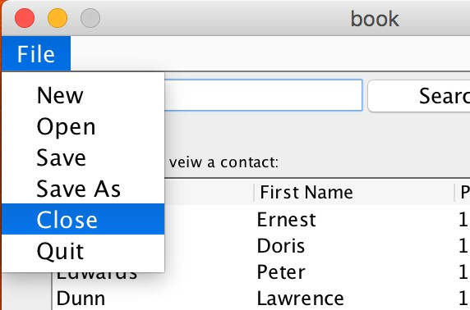

Figure 34: Select Close



Figure 35: Save Prompt

# 14 Quitting the Application

## 14.1 Overview

If you wish to stop using the Address Book application follow the procedure below to do so.

## 14.2 Procedure

**1**) **Begin at the Main Page of the Address Book** Make sure you are at the Main page of the Address Book.



Figure 36: Full Main Page

#### 2) Select the File Menu

At the top of the Main page window there will be a button that reads ”File”. Select it and a menu will pop open.



Figure 37: File Menu

#### Select ”Quit”

Click the ”Quit” and the Address Book application will close. Unless the Address Book(s) haven’t been previously saved, then a pop up will appear prompting you to Save the file(s).

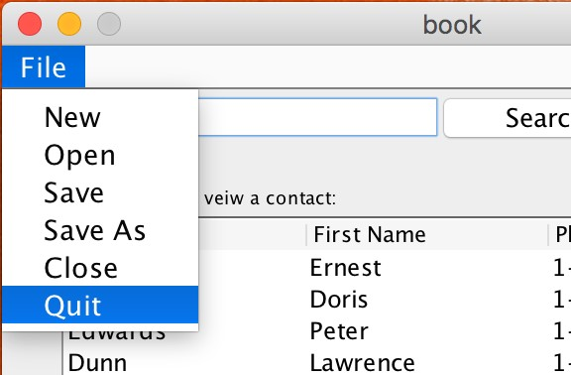

Figure 38: Select Quit



Figure 39: Save Prompt